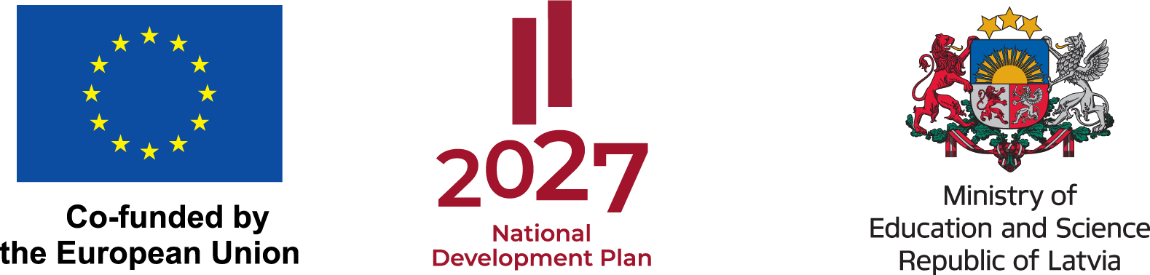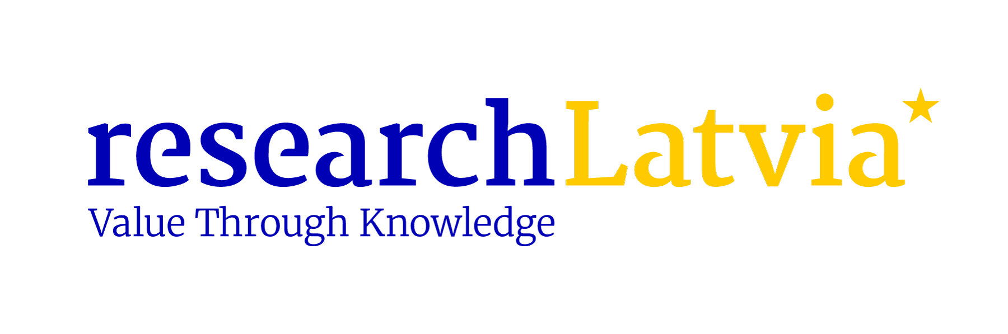

Presentation of the Results of the International Evaluation of Scientific Institutions

Date: 9 April 2026
Location: University of Latvia House of Science, auditorium Alfa, 1st floor
Address: Jelgavas iela 3, Rīga
11:30-14:00

Agenda

Time | Session | Speakers
11:30-11:45 | Arrival, coffee
11:45-11:55 | Opening by the Ministry of Education and Science | Representative of Ministry of Education and Science
11:55-13:00 | Presentation of evaluation results:  - Overview of the evaluation process and methodology  - Key results across disciplines  - Cross-cutting observations and system-level findings  - Implications for the research system | Anete Vingre and Erik Arnold, Technopolis
13:00-13:30 | Q&A and open discussion on evaluation results and future directions | All, moderated by Technopolis
13:30-14:00 | Closing and coffee

